**R&I Best Practices for Google Cloud**

**21st August 2024**

# STAKEHOLDERS

## Internal

Riad Bacchus and Jeremiah Chuang have the input on these

## External

Cheryl Mackinnon sets priorities and can override anything in this document

# OVERVIEW

Using Google Cloud for reporting and insights workflows and methods has some non-intuitive processes. These are detailed here

**Deadlines**

Microsoft will be totally gone in October. Some R&I team members will retain access to things such as Excel & Power BI.

# PREREQUISITES

## Power BI License & Permissions

* Developer can either have Power BI Premium per User (PPU) or Power BI Pro license
* The Developer needs access to workspaces for Dataflows, testing, and production environments
* Recommended, but Optional: The Developer may need ability to export files (.pbix and .xlsx)

## Google Account

IT takes care of this Just email [itservicedesk@saddleback.com](mailto:itservicedesk@saddleback.com)

## Google Drive access permissions

IT takes care of this. Just email [itservicedesk@saddleback.com](mailto:itservicedesk@saddleback.com)

# Cutover Procedures

## File storage

# 

# 

*Before*: Egnyte/Sharepoint/local computer

*After*: Shared Google Drive File repositories

*For .pbix reports:* [Report Version Files](https://drive.google.com/drive/folders/1OXIYo832jqS85MZihAn2stGflIV09Jzw)

*For Data sources:* [Data Sources for Reports](https://drive.google.com/drive/folders/1XpdH88Qudlbl1nhPYP5DFPf06KDLtWiy?usp=drive_link)

### Converting Excel documents to Google Sheets

[Power BI to Google Sheets Guide](https://docs.google.com/document/d/1NofWVdpc-_ZErz_t6dGTXN0vSWjj9R7lpg6o3pIXg64/edit?usp=sharing)

*Comments on Power Query formatting*

* Nulls turn into blanks
* Extra rows in the Google Sheet become rows in Power Query
  + Filter these out in Power Query

# New Methods

## Chat and Collaboration

* Google doesn't have the ability to name a group chat.
* However, we could convert this group chat into a Space, which would facilitate chat, threads, and file sharing. *Only if we need it*

## File Sharing

Google Sheets require certain permissions for Share > Link > Manage Access. Depending on if any users are external to the organization, they may need the Google Sheet to be open to “Anyone with the link”

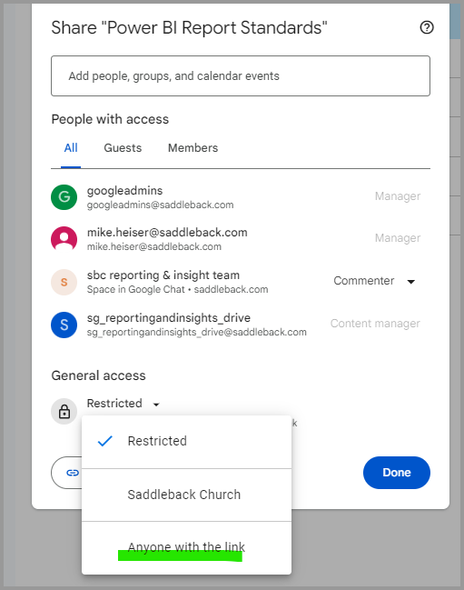

## Desktop to Drive Integration

Google Drive can sync folders on your computer with those in your Drive so you don’t have to manage multiple copies of files.

1. [Download](https://support.google.com/drive/answer/10838124?hl=en#zippy=%2Cinstall-set-up-drive-for-desktop-for-windows) & [Sign In](https://support.google.com/drive/answer/10838124?hl=en#zippy=%2Csign-in-to-drive-for-desktop) when prompted
2. [Access](https://support.google.com/drive/answer/10838124?hl=en#zippy=%2Caccess-your-files-when-theyre-synced) or Add folders/files to your new Google Drive (G:) > My Drive
3. Click Gear > Preferences > Syncing options > select “Mirror Files”
   1. Reports are large files, which means [Streaming (default)](https://support.google.com/drive/answer/13401938?sjid=11225657653444883599-NC) has longer sync times

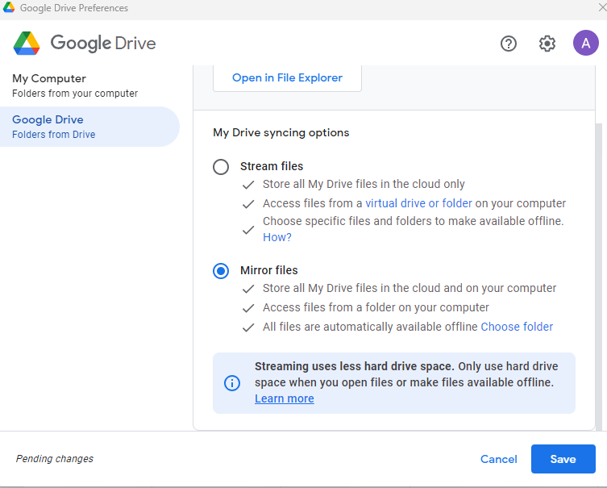

## Report Development and revisions

* Check that for each report, Google Drive has a file folder structure for these 4 folders
  + 01_Report Repository
  + 02_Report Objects
  + 88_Testing
  + 99_Production
* Download .pbix from Google Drive
* Follow Version Control process and update hidden pages within .pbix. [PBI Version Control Process v2.pdf](https://drive.google.com/file/d/1Ep3se4Ju_khYNchofEl3ZCM20zuFVFav/view?usp=drive_link)
* Save versions to Google Drive as .pbit for backup into 01_Report Repository (each report should have this folder)

**QA in (DEV) workspaces**

Same as before

**Visualization**

Same as before. See this folder for standard guidelines: [Power BI Report Standards](https://drive.google.com/drive/folders/1PY7gEnQOi2jdAzU_O63IbP1IRAm9VIRC?usp=drive_link)

# Deploying Reports

## Power BI Service (Browser based)

If a semantic model is using Google Sheets, then the credentials have to be input into the settings.

## Exports

Currently the Power BI button for Export data produces a file in Excel. The best user experience would convert these extracts into Google Sheets seamlessly.

[Power BI to Google Sheets Guide](https://docs.google.com/document/d/1NofWVdpc-_ZErz_t6dGTXN0vSWjj9R7lpg6o3pIXg64/edit?usp=sharing)

# Potential Ideas to try

Google sheets can make templates. We could use this to standardize visuals on extracts

Work in progress page

Stuff you can do now BEFORE go-live:

* Use [chat.google.com](http://chat.google.com/), not [gmail.com](http://gmail.com/)
* *Spaces*:
  + External member access: Set only at creation
    - Enables "Copy link to this space" button
  + *Threads*: a method to focus conversations & Reduce notifications for other team members.
  + Configurable notifications
* MEET:
  + Intuitive interface
  + Auto-frame camera setting
  + *Companion Mode*: For conference rooms, no audio
  + Calendar integration:
    - Meet options in G-Cal events
    - Attachments visible in Meet
  + R&I team will Use *Contributors*, not Viewers role

AFTER go-live:

* Best practice: continue to use [chat.google.com](http://chat.google.com/), not [gmail.com](http://gmail.com/)
* Strong recommendation: Switch to Chrome browser
  + Import bookmarks